Mobile Applications: Design Document

Created by Kenneth Mallabo

Last Updated: 26/04/2023

# Introduction

This document is a design document for the project proposed for the Mobile Applications module. The project should be an Android app that would illustrate/teach a math/physics concept The project idea proposed is a mobile app that illustrates the Doppler effect using the Samsung S21's microphone. The app would show a frequency graph that updates according to the sound picked up by the microphone. The user would be able to move around a sound source (e.g., a speaker) and observe how the frequency graph changes as the sound moves away and towards them. The name of the mobile application is Doppler.

# High Level Description

The mobile application requires 3 activities but with one optional activity, the main activity, the video/tutorial activity, the sound visualiser activity and a bonus activity.

* The main activity is basically the main menu of the app for the other activities and the first thing the user sees.
* The video activity is simply embedding a YouTube video explaining the Doppler effect.
* The sound visualiser activity will feature a visual representation of the played sound. It would also include buttons that allows the audio to be rewind, play the audio, record an audio using the microphone and then a button to stop the recording.
* Originally the fourth activity would be a muted visualiser that the user would have to guess what the sound may be in a multiple-choice question format. Once the user has chosen their answer, a toast pops up to tell the user if their answer was correct or not. Then the activity would play another visualiser with different multiple-choice questions. Although it has been pointed out that this question does not properly educates or show how the Doppler effect works. A potential alternative could be an option to add a settings activity that would enable or disable dark mode and able to choose different sound visualiser effects.

The application uses a GitHub repository called the Android Audio Visualizer (<https://github.com/GautamChibde/android-audio-visualizer>). This repository provides 6 sound visualiser effects:

**Line bar visualizer**



Figure 1: Line bar visualiser example

Another notable library used is the android-youtube-player (<https://github.com/PierfrancescoSoffritti/android-youtube-player#sample-app>). This library allows embedding a customisable YouTube player to be embedded on an activity or fragment. This library takes advantage of Google’s Youtube player API that embeds a YouTube video player on a website and control the video player using JavaScript. The API has functions such as queueing videos, play, pause, adjust player volume etc. The library wraps around this API which runs inside of a Webview.

# Code

## General overview of app

There are some java programs in the project that are from the AudioVisualiser GitHub repository or cut content such as QuizActivity.java that are left alone but are not being executed. Therefore, there are only five in use;

* MainActivity.java: This program sets the activity_main.xml for its layout and enables intents for the other java programs/activities.
* BaseActivity.java: This program is used for the visualiser code. It contains methods to recording audio such as setting the audio, stopping it, requesting permission to the microphone, start and stop recording. Recorded audio is stored in the external cache and encoded as 3gp file.
* MediaPlayerService.java: The program provides handling specifically for the audio functions such as pause(), start(), isPlaying(), replay() and providing a default audio to play.
* ActivityTutorialVideo.java: It sets layout from the activity_tutorial_video.xml file enables the YouTube video player.
* LineBarVisualizerActivity.java: This program is an extension of BaseActivity and includes additional functionalities such as init() which configures the visualiser such as its color, number of bars and setting the mediaplayer to the visualiser.

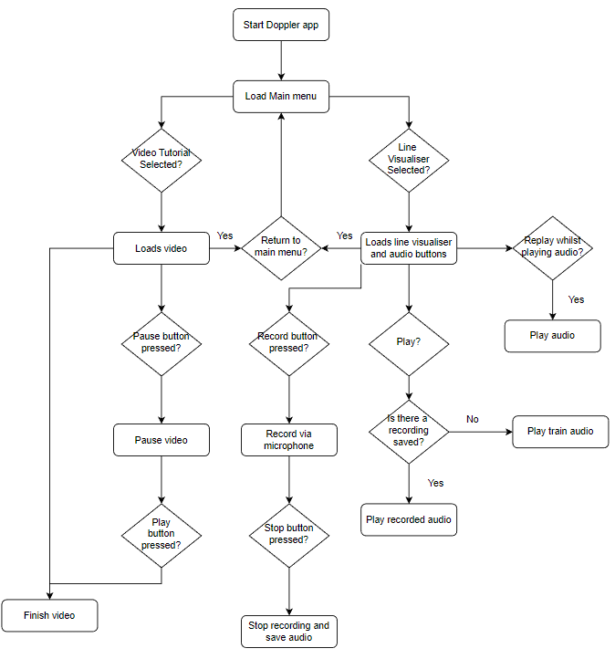

Figure 2: Flowchart of applications operations

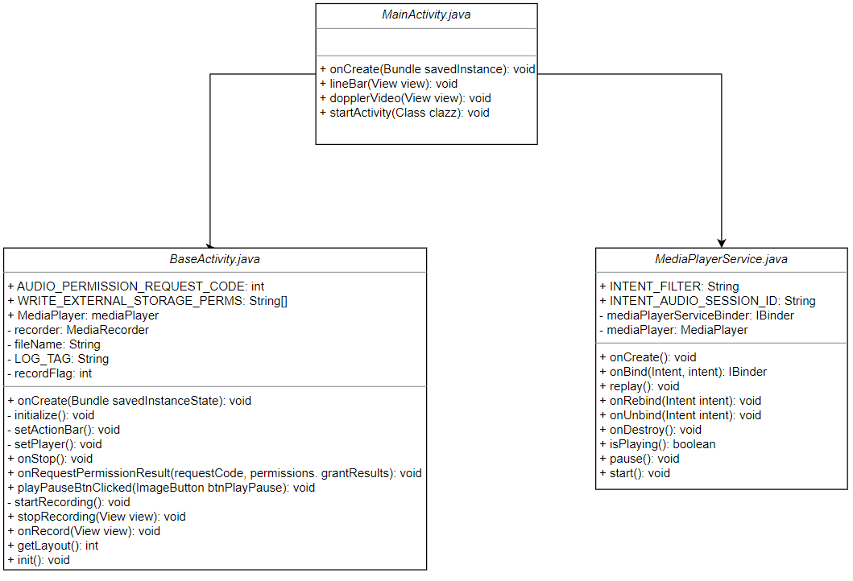

Figure 3: UML diagram of .java programs

## Persistent Storage

When the user has stopped recording, the audio is stored on the device itself. Specifically on the app’s cache directory with the name “audiorecordtest.3gp” using the 3GP file format. 3GP is a multimedia file that is saved in a video and audio container format. It was originally designed to be transmitted between 3G mobile phones and over the internet. However, it can also be placed on 2G and 4G phones.

# Application GUI Design

The application has been designed with some of the usability heuristics:

**Match between system and the real world**

This means that the application should words, phrases and concepts that are generally familiar to people instead of internal jargon. An example of this, is in figure 5 where the microphone button has button to signify recording an audio using the phone’s microphone sensor.

**User control and freedom**

It states that there should be a clear undo or exit functionality. Both figure 4 and 5 have a left arrow button on its action bar to show the user that they can return to the main menu when pressing that button.

**Consistency and standards**

This enforces that typical conventions and etiquettes should be followed to prevent confusion. The app adheres to this on figure 4 and 5 when using the play and pause button that are universally used in all media players.

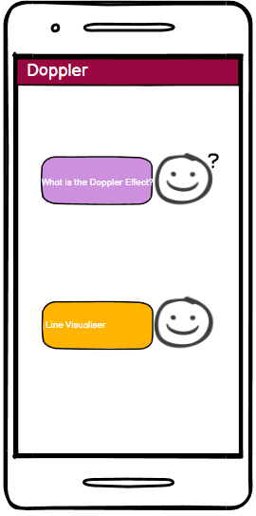

Figure 4: Main activity

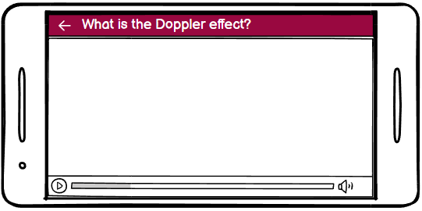

Figure 5: Video activity

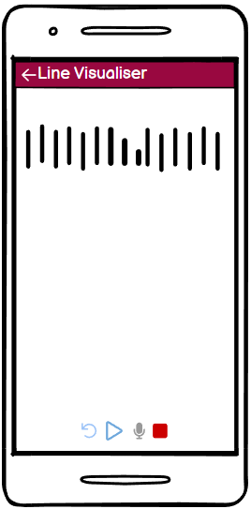

Figure 6: Line visualiser activity

There are twelve .xml layouts in the project but only 4 are being used in the mobile application. They are:

* activity_line_bar_visualizer.xml
* activity_main.xml
* activity_tutorial_video.xml
* layout_audio_buttons.xml

# References

PierfrancescoSoffritti (2023). *android-youtube-player* [online]. Available from: <https://github.com/PierfrancescoSoffritti/android-youtube-player#sample-app> [accessed 10 March 2023].

Jarrod Lilkendey (n.d.). *How to Embed YouTube Videos in an Android App with android-youtube-player* [online]. Available from: <https://learntodroid.com/how-to-embed-youtube-videos-in-an-android-app-with-android-youtube-player/> [accessed 20 March 2023].

Android (2021). *MediaRecorder overview* [online]. Available from: <https://developer.android.com/guide/topics/media/mediarecorder> [accessed 16 March 2023].

Nielsen Norman Group (2020). *10 Usability Heuristics for User Interface Design* [online]. Available from: <https://www.nngroup.com/articles/ten-usability-heuristics/> [accessed 2 April 2023].

FileInfo.com (2022). *3GPP Multimedia File* [online]. Available from: <https://fileinfo.com/extension/3gp> [accessed 26/04/2023].